**NutriApp**



University of Missouri-Kansas City

**Spring 2020**

**Date:** Apr 30 - 2020

**Course:** COMP-SCI 5551

**Class:** Advanced Software Engineering

**Team Members (Team 3):**

1. Abbas Alshaikh
2. Claude Aloumon
3. Jonathan Wolfe
4. Bill Yerkes

**Project Final Report**

**Motivation**

With about 2/3 of Americans being overweight or obese, obesity is a major health concern in the US.1 Obesity leads to many other health complications that account for most deaths in the US.1 A good diet is the basis of a healthy life and weight reduction.2 Maintaining a good diet can be difficult and tracking the nutritional data of the foods consumed can be a large task.

**Significance of Project**

This application simplifies the process of tracking your consumed foods by keeping the data of the calories consumed through a mobile device or web browser. Users will be able to use voice recognition technology to input the information about the consumed foods. The application then retrieves the nutritional information of those foods and stores it in a cloud server.

**Scope of Project**

· The project will utilize existing food databases to interpret the input meals

· The project will utilize a voice recognition API to interpret input

· Data will be stored to each individual account on a cloud database

· Personal identifying information will not be collected

· Users will not be able to access another user’s information

· Each user will have a unique account

· Recommendations will not be provided

· The system will not support adding new food items

**Objectives of Project**

Calorie control is not so much about restricting your diet as it is about considering your food options and keep up with your health meter. However here is a list of project objectives:

1- Watch your calorie consumption.

2- You are making better choices with this app.

3- Simply, it's a free app.

**Features**

· Individual account to store nutritional data

· Input a food name and amount then retrieve its nutritional info

· Display amount of usage (daily/monthly/annul).

· Input information by voice (voice recognition)

· Display nutritional information of an account in an easy to understand graph

**Stretch Goals**

· Determine user BMI and caloric requirements

· Compare recommended daily allowance for the individual to their consumption

· Provide support for pediatric accounts

· Ability to add custom food information

**Target Audience**

NutriApp is usable for all genders, all ages and every nationality users and supports only English language. Also it’s Hybrid app (web app + phone app).

**Implementation**

here is a list of used tech and platforms;

* MySQL.
* ExpressJS.
* Angular 8.
* NodeJS.
* Ionic.
* WebStorm.
* Adobe Photoshop.

**Detail Design of Features**

***Wireframe***

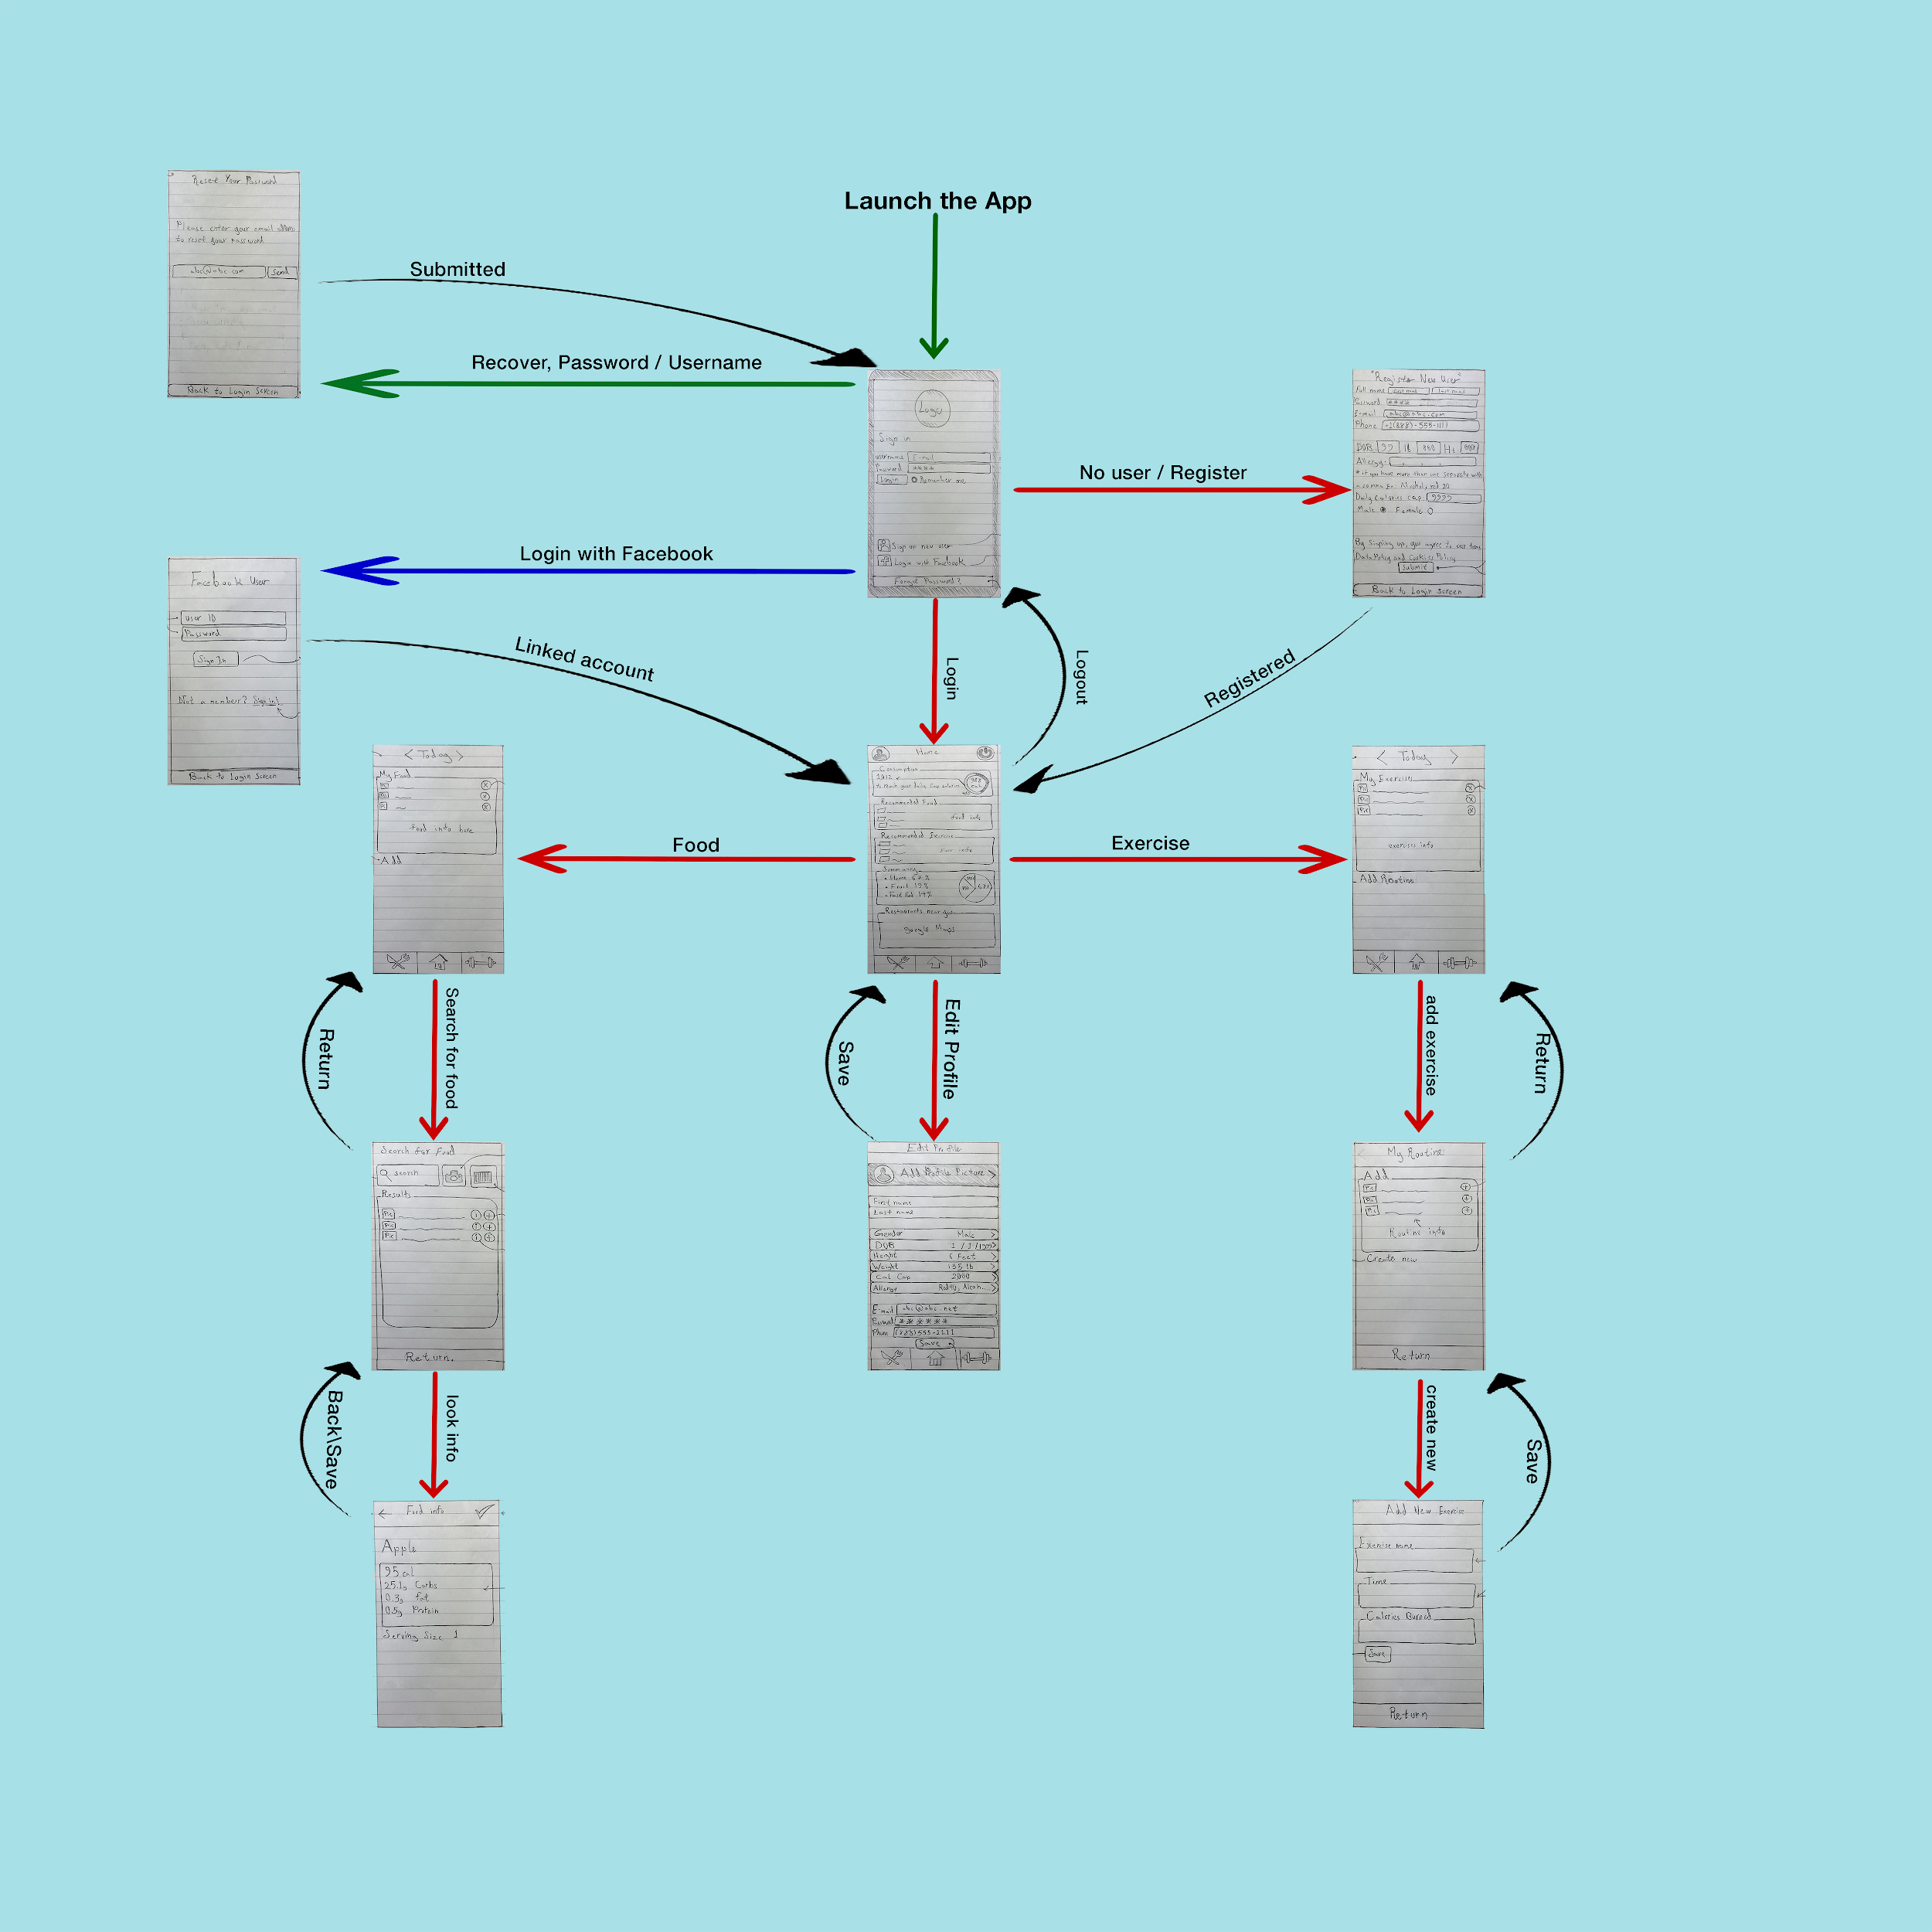

***State Diagram***

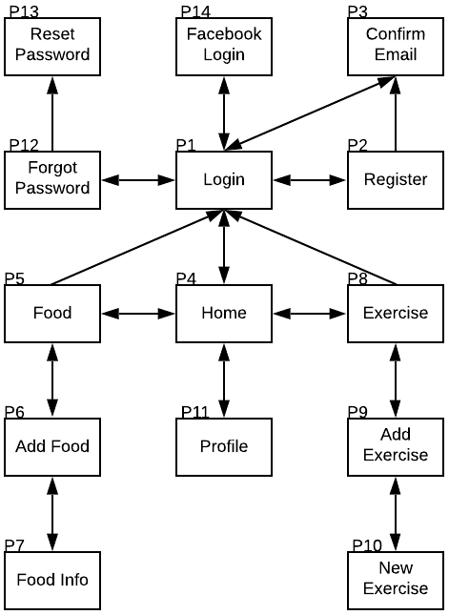

**Class Diagram**

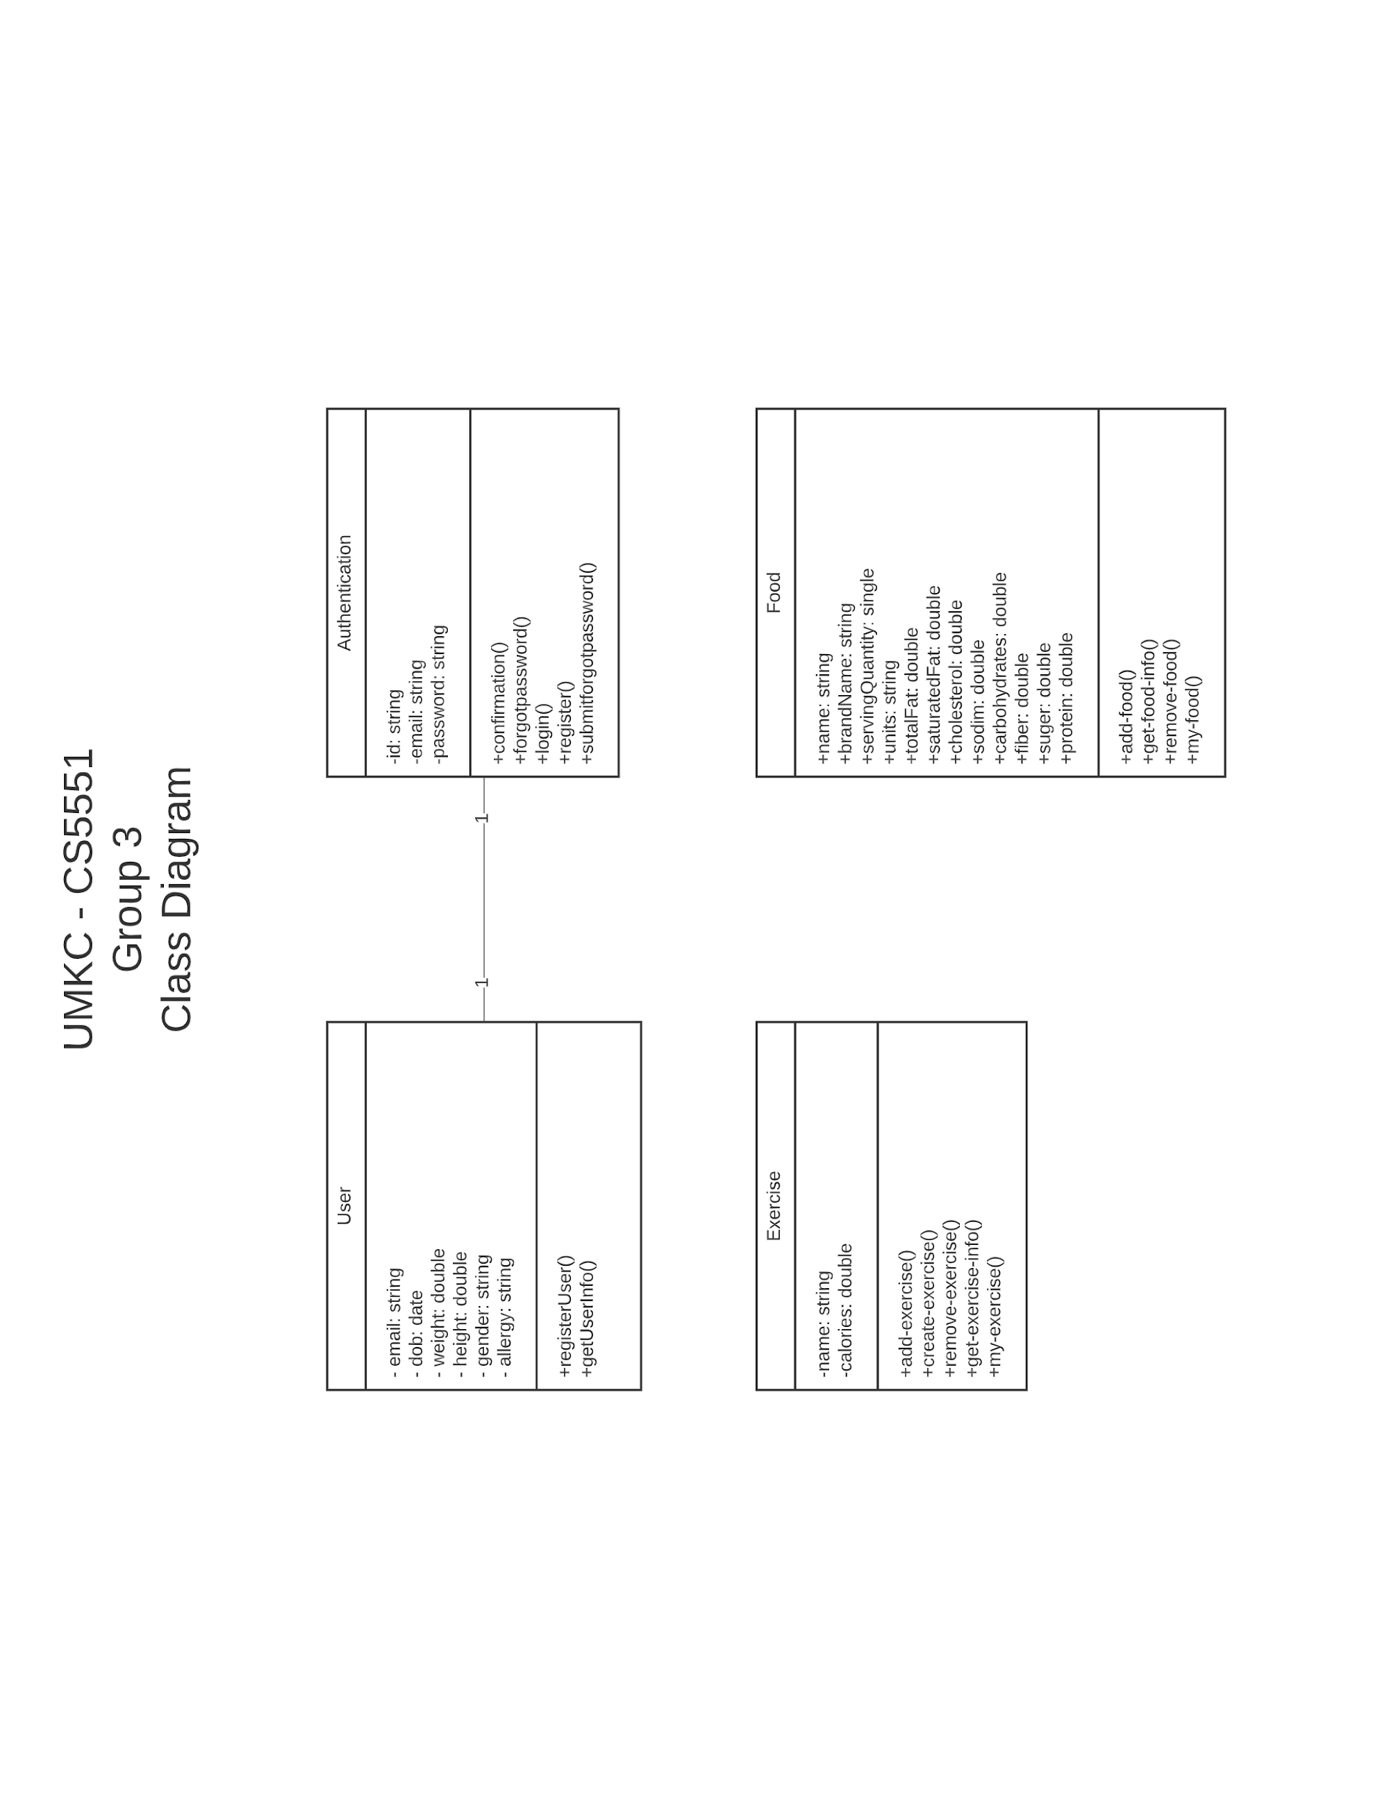

**User Functions:**

*Login Page;*

* Register
* Recover password
* Login
* Logout
* Remember me

*Home Page;*

* Update user info
* Get a summary
* Get recommendations
* Find restaurant nearby

*Food Page;*

* Search for food
* Add food
* Create food 'manually'
* Add food by picture
* Delete food
* Scan a barcode

*Exercise Page;*

* Search for an exercise
* Add exercise
* Create exercise
* Delete exercise

**User Stories & Use Case**

|  |  |  |  |  |  |
| --- | --- | --- | --- | --- | --- |
| Story ID | Theme | As a/an | I want to... | so that... | Priority |
| 1 | Login | Unregistered User | create an account | I can access user content | Very High |
| 2 | Login | Unregistered User | create an account through Facebook | I can let facebook handle my login | Low |
| 3 | Login | Registered User | reset my password | I can access my account | Very High |
| 4 | Login | Registered User | set my account to remember my login | I do not need to login every time | Medium |
| 5 | Profile | Registered User | review my personal information | I can verify correctness | High |
| 6 | Profile | Registered User | change my allergies | I can avoid foods I am allergic | High |
| 7 | Profile | Registered User | change my weight | I can get correct estimates | High |
| 8 | Profile | Registered User | change my height | I can get correct estimates | Medium |
| 9 | Food | Registered User | scan a barcode | I can add a food | Very High |
| 10 | Food | Registered User | take a picture of my food | I can identify the food so I can add it | Very High |
| 11 | Food | Registered User | manually enter the food I ate | I can add a food | Very High |
| 12 | Food | Registered User | review the foods I ate today | I can verify correctness | Very High |
| 13 | Food | Registered User | review the foods I ate on a specific date | I can verify correctness | Medium |
| 14 | Food | Registered User | remove a food I ate today | I can correct the foods I ate | High |
| 15 | Food | Registered User | add a food to a specific day | I can fill the system with info I have | Medium |
| 16 | Food | Registered User | create a new food item | I can add a custom food | Low |
| 17 | Food | Registered User | remove a food to a specific day | I can fill the system with info I have | Low |
| 18 | Food | Registered User | get a warning about allergies | I can avoid the food | High |
| 19 | Exercise | Registered User | review exercise I did today | I can verify correctness | Very High |
| 20 | Exercise | Registered User | review exercise I did on a specific date | I can fill the system with info I have | Medium |
| 21 | Exercise | Registered User | create an exercise routine | I can save and use the routine | Very High |
| 22 | Exercise | Registered User | add a routine for today | I can track my exercise | Very High |
| 23 | Exercise | Registered User | remove a routine for today | I can track my exercise | High |
| 24 | Exercise | Registered User | add a routine for a specific date | I can fill the system with info I have | Medium |
| 25 | Exercise | Registered User | remove a routine for a specific date | I can fill the system with info I have | Low |
| 26 | Exercise | Registered User | review exercise I did today | I can verify correctness | Very High |
| 27 | Home | Registered User | get my net calorie loss for today | I can learn how to improve my weight | Very High |
| 28 | Home | Registered User | get my net calorie loss for a specific date | I can learn about my progress | Low |
| 29 | Home | Registered User | get a recommended food | I can improve my diet | High |
| 30 | Home | Registered User | get a recommended exercise | I can improve my exercise | High |
| 31 | Home | Registered User | find a restaurant serving a food item | I can get the food | Medium |
| 32 | Home | Registered User | get a summary of my food stats for today | I can learn more about my diet | Medium |

**Testing**

**Test Cases**

|  |  |  |
| --- | --- | --- |
| **Test Case ID** | **Scenario** | **Expected Results** |
| TF01 | Empty field in the search food box | Warning of improper input |
| TF02 | Spaces only in the search food box | Warning of improper input |
| TF03 | Food not found | Warning of food not found |
| TE01 | Empty field in the search exercise box | Warning of improper input |
| TE02 | Spaces only in the search exercise box | Warning of improper input |
| TE03 | Exercise not found | Warning of improper input |

**Test Case Document**

[**https://github.com/JAWolfe04/CS5551-Group-Project/blob/master/TestCases.ods**](https://github.com/JAWolfe04/CS5551-Group-Project/blob/master/TestCases.ods)

**Performance Tests**

|  |  |
| --- | --- |
| **Performance case ID** | **Scenario** |
| PF01 | Loading My Food page response time with 1 user is less than 1 second |
| PF02 | Searching Food response time with 1 user is less than 1 second |
| PF03 | Adding Food response time with 1 user is less than 1 second |
| PE01 | Loading My Exercise page response time with 1 user is less than 1 second |
| PE02 | Searching Exercise response time with 1 user is less than 1 second |
| PE03 | Adding Exercise response time with 1 user is less than 1 second |

**Implementation**

* Angular 8
* Ionic
* MySQL
* NodeJS
* Express JS

**Existing Design/Services/REST API**

We are using Amplify and AWS Cognito to handle login services. We plan to use Nutritionix API for food querying and Clarifai for food recognition. Also we are using Google Maps JavaScript API to show restaurants nearby based on user current location.

**Deployment**

Here is list of changes ( These are only changes are made for Iteration 2)

**Login Page (UI changed) Register Page (UI changed)**

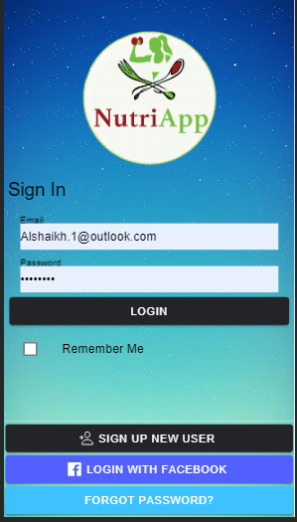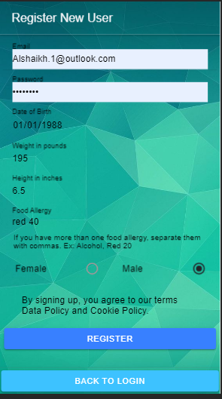

**Profile Page (to edit & save user info) Reset password Page (to edit & save user info)**

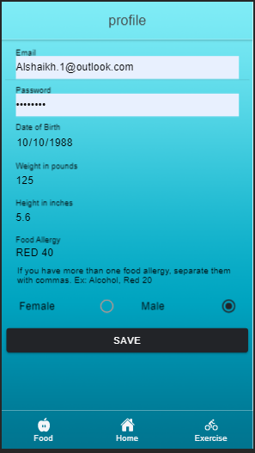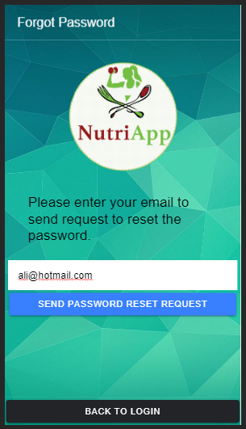

**Home Page (Fix divider) Home Page (add more sections)** 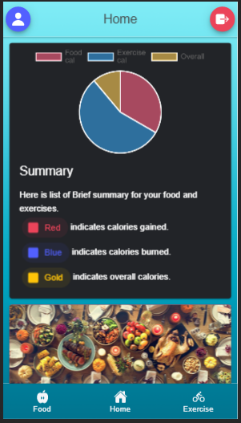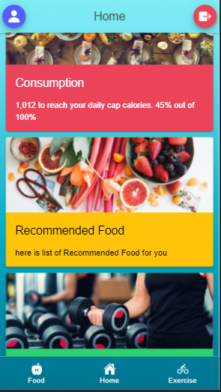

**Exercise Page (if no exercise added) Exercise Page (if exercise added)**

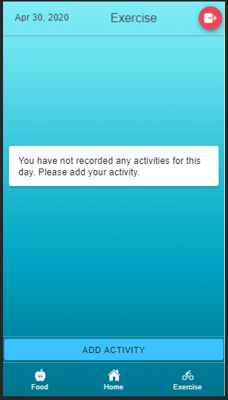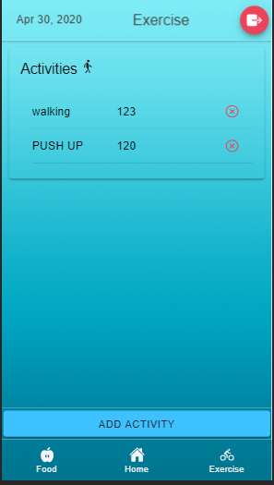

**Exercise Page (creating new exercise) Exercise Page (deleting an exercise action)**

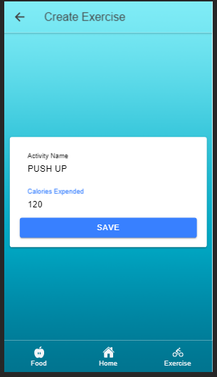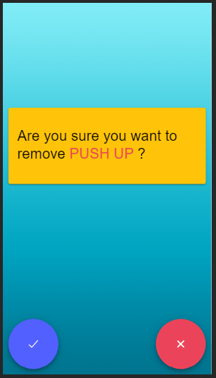

**Exercise Page (search for an exercise) Exercise Page (displays exercise based on date)**

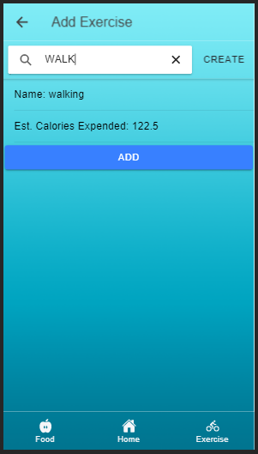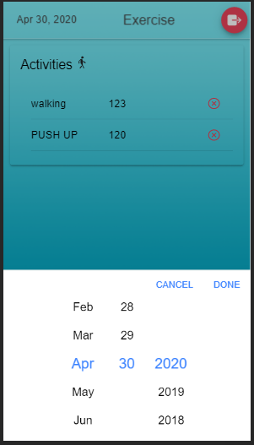

**Food Page (if no food added) Food Page (if food added)**

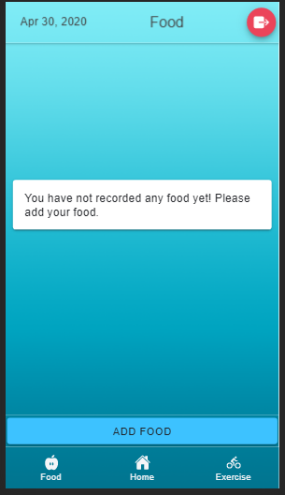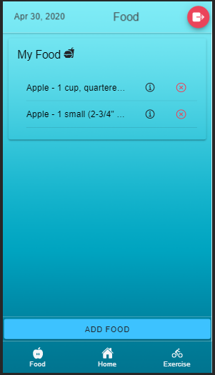

**Food Page (search for food) Food Page (deleting food action)**

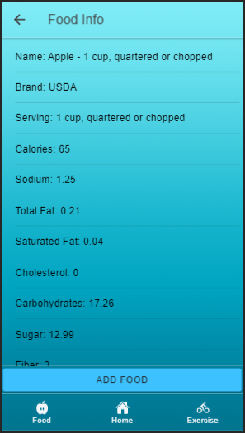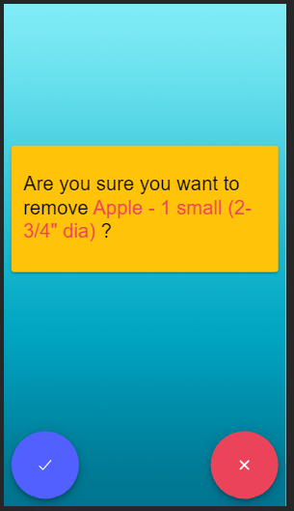

**Food Page(displays food based on date) Add Food(displays food info to add)**

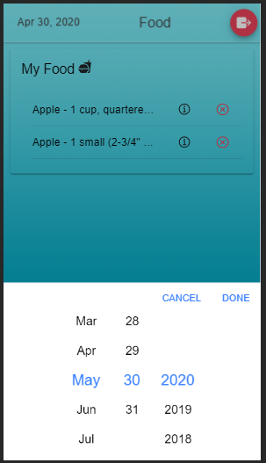

**Work completed (in hours)**

|  |  |  |  |  |  |
| --- | --- | --- | --- | --- | --- |
| **Task** | **Abbas** | **Bill** | **Claude** | **Jonathan** | **Total** |
| **Set Up Environment** | **1** | **1** | **1** | **2** | **5** |
| **Pick APIs** | **2** | **2** | **2** | **2** | **8** |
| **Design App** | **4** | **4** | **4** | **4** | **16** |
| **Design database/tables** | **1** |  | **2** |  | **3** |
| **Create User Stories** | **2** |  |  |  | **2** |
| **Create database/tables** |  |  | **4** |  | **4** |
| **Setup AWS Authentication** | **2** | **2** | **2** | **30** | **36** |
| **Setup AWS Database** |  | **1** |  |  | **1** |
| **Setup App Server** |  |  |  | **3** | **3** |
| **Create basic exercise page** | **1** |  |  |  | **1** |
| **Create basic food page** | **1** |  |  |  | **1** |
| **Create basic add exercise routines page** | **1** |  |  |  | **1** |
| **Create Add Exercise page** | **1** |  |  |  | **1** |
| **Create Add Food page** | **1** |  |  |  | **1** |
| **Create wireframes** | **4** |  |  |  | **4** |
| **Create Site Map** | **3** |  |  |  | **3** |
| **Create User Profile page** |  |  |  | **1** | **1** |
| **Create unit testing** |  | **3** |  | **1** | **4** |
| **Create Iteration 1 Report** | **3** | **3** | **3** | **6** | **15** |
| **Create Add Food Button in My Food page** |  |  |  | **0.5** | **0.5** |
| **Create and add navigation to Search for Food page** |  |  |  | **0.25** | **0.25** |
| **Create a return button for Search for Food page** |  |  |  | **0.25** | **0.25** |
| **Add search bar and button** |  |  |  | **1** | **1** |
| **Pull Food info from Food AP** |  |  |  | **1.5** | **1.5** |
| **Create List results of search** |  |  |  | **2.5** | **2.5** |
| **Create and add navigation to Food Info page** |  |  |  | **0.25** | **0.25** |
| **Create a return button for Food Info Page** |  |  |  | **0.25** | **0.25** |
| **Populate display with food item info** |  |  |  | **1** | **1** |
| **Create confirmation button** |  |  |  | **0.25** | **0.25** |
| **Create handler to send food to database** |  |  |  | **1** | **1** |
| **Add food item to list in My Food page** |  |  |  | **0.75** | **0.75** |
| **Create My Food Page** |  |  |  | **1** | **1** |
| **Pull food items from the database** |  |  |  | **3** | **3** |
| **Create list to display food items** |  |  |  | **4** | **4** |
| **Create database food table** |  |  |  | **1** | **1** |
| **Create datetime picker** |  |  |  | **1** | **1** |
| **Handle requests with a specific time** |  |  |  | **1** | **1** |
| **Create remove button in the food list in the My Food Page** |  |  |  | **0.1** | **0.1** |
| **Create remove food confirmation popup** |  |  |  | **1.5** | **1.5** |
| **Remove food item from database** |  |  |  | **1** | **1** |
| **Remove food item from list** |  |  |  | **0.25** | **0.25** |
| **Create My Exercise Page** |  |  |  | **0.25** | **0.25** |
| **Create list to display exercise** |  |  |  | **0.5** | **0.5** |
| **Pull exercise data from database** |  |  |  | **1** | **1** |
| **Create exercise SQL Table** |  |  |  | **1** | **1** |
| **Create add exercise button in My Routine page** |  |  |  | **0.1** | **0.1** |
| **Create and add navigation to Add New Exercise Page** |  |  |  | **0.1** | **0.1** |
| **Create return button to Add New Exercise Page** |  |  |  | **0.1** | **0.1** |
| **Create method to send exercise data to the database** |  |  |  | **0.1** | **0.1** |
| **Create Add exercise form** |  |  |  | **0.1** | **0.1** |
| **Add new exercise to routine list in the My Routine page** |  |  |  | **0.1** | **0.1** |
| **Create Add Routine Button to My Exercise page** |  |  |  | **0.1** | **0.1** |
| **Create and add navigation to My Routine Page** |  |  |  | **0.1** | **0.1** |
| **Create return button for My Routine page** |  |  |  | **0.1** | **0.1** |
| **Create search bar to query API for exercise info** |  |  |  | **0.1** | **0.1** |
| **Query API** |  |  |  | **0.25** | **0.25** |
| **Create method to get user attributes for personal query** |  |  |  | **1.5** | **1.5** |
| **Create display exercise info with add button** |  |  |  | **1** | **1** |
| **Add exercise to My Exercise list** |  |  |  | **0.25** | **0.25** |
| **Create remove button** |  |  |  | **0.1** | **0.1** |
| **Create removal modal** |  |  |  | **0.1** | **0.1** |
| **Create a methods to remove exercise** |  |  |  | **0.1** | **0.1** |
| **Create User Stories** |  |  |  | **2** | **2** |
| **Update Project Backlog** |  |  |  | **1** | **1** |
| **Create Sprint 2 Backlog** |  |  |  | **4** | **4** |
| **Food Pages Bug Fixes** |  |  |  | **3** | **3** |
| **Create Sprint 2 Report** | **2** | **2** |  | **2** | **6** |
| **Designing home page** | **2** |  |  |  | **2** |
| **Pull stores from google maps API** | **10** |  |  |  | **10** |
| **Pick & design images** | **0.3** |  |  |  | **0.3** |
| **UI Designing** | **30** |  |  |  | **30** |
| **Google Maps API** | **14** |  |  |  | **14** |
| **Pie-chart Graph Summary** | **9** |  |  |  | **9** |
| **Create Profile Page** | **2** |  |  |  | **2** |
| **Created Increment 3 Report** | **2** | **2** | **2** | **2** | **8** |
| **Linked Home Page to Nutrition Data** |  |  |  | **1** | **1** |
| **Barcode Reader** |  | **10** |  |  | **10** |
| **Create Final Report** | **2** | **4** | **2** |  | **8** |
| **Total** | **100.3** | **34** | **22** | **94.4** | **250.7** |

**Work to be completed**

|  |  |  |
| --- | --- | --- |
| **Task** | **Estimated Hours** | **Responsibility** |
| Add Clarify AI | 10 | Jonathan |
| Add Allergy Warnings | 3 | Any |
| Add Suggested Restaurants | 10 | Abbas |

**Issues/Concerns**

* Unable to complete the project as proposed in the project plan.
* Amplify framework is difficult to use in a team setting.
* Food recognition will be inaccurate in identifying foods.
* AWS services and APIs may cost money to implement the project.

**Future work**

* Add Barcode Scanning.
* Add Clarify AI.
* Add Homepage stats by user.
* Add Suggested Restaurants.
* Add Food recognition.

**Conclusions**

The application is almost ready, 98% of the plan is done but it needs final touch such as extracting the application as .apk or .ipa extensions and launching it on app stores. Also, it needs a host to upload the project on the server in order to browse it via PC browser.

**References:**

1. Hurt RT, Kulisek C, Buchanan LA, McClave SA. The obesity epidemic: challenges, health initiatives, and implications for gastroenterologists. Gastroenterol Hepatol (N Y). 2010;6(12):780–792.

2. Strychar I. Diet in the management of weight loss. CMAJ. 2006;174(1):56–63. doi:10.1503/cmaj.045037

**Used APIs:**

Food Database API: <https://developer.edamam.com/food-database-api>

**Github:**

<https://github.com/JAWolfe04/CS5551-Group-Project>

**Github Wiki:**

<https://github.com/JAWolfe04/CS5551-Group-Project/wiki>

**Proposal & Plan Report** <https://github.com/JAWolfe04/CS5551-Group-Project/blob/master/Documentation/ASE%20-%20Project%20Proposal.docx>

**Iteration 1 Report**

<https://docs.google.com/document/d/14yDBMsxUxv15iAzryIxjxfX5DgJQHZorXQJZgu5DOjc/edit?usp=sharing>

**Iteration 2 Report**

<https://docs.google.com/document/d/1-UAkeV0U-K2epvHMWvbDzq-T8C94Cs6AYqFaT3fWGvc/view>

**Iteration 3 Report**

<https://docs.google.com/document/d/1-uj6aKaq9dsOS2bx5jM7D0amj8hl9R9owSbXno8KZJk/view>